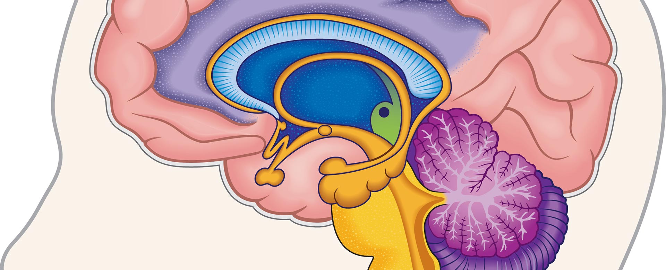ILLUSTRATION BY JIM KOPP FOR TIME FOR KIDS

The Science of Brainpower
Experts say you have the ability to boost your intelligence.
By Suzanne ZimblerJuly 20, 2015
Last year, Kayla Thompson dreaded math class, especially when it came to computing with fractions. “I knew there was only one correct answer,” says Kayla. “And when I didn’t get it, I felt discouraged.”
This year, Kayla, now in middle school, has a different point of view. Since September, she and her classmates at Lenox Academy, in Brooklyn, New York, have been taking a course called Brainology. The program teaches that the brain works like a muscle: The more you use it, the stronger it gets.Now, when Kayla comes up against a challenge in math, she doesn’t shut down. And she doesn’t feel so bad about making mistakes, either. After all, she says, “mistakes help us learn.”

Work Your Brain!
Psychologist Carol Dweck, at Stanford University, in California, developed Brainology after years of studying students’ attitudes toward learning. She found that when kids realize it’s possible to increase their intelligence, they do better in school. “We teach kids that every time they work on something hard and stick to it, their brain forms stronger connections. And these connections can make them smarter,” she says.
So how can you give your brain a good workout? When you have a choice between an easy task and a challenging one, says Dweck, you should always take the challenge. “Struggle is good,” she says. “Working hard at something really grows your brain.”
Dweck also recommends embracing mistakes. “When you make a mistake, don’t run away from it,” she says. “Instead, think about it. Ask your teacher about it.” And that subject you say you’re not good at? According to Dweck, you should change how you think about it and give yourself room to grow. Tell yourself: “I’m not good at it yet.”
Salman Khan, founder of the free educational website khanacademy.org, agrees with Dweck. “As soon as you say you’re not good at something, then you’ve pretty much closed the door,” Khan says. Instead, he says, you should keep trying and seek help. He says one place to look for help is Khan Academy. Millions of people around the world have used the site’s videos and practice exercises to master skills. “You can learn at your own pace, keep pushing yourself, and go as far as you want to go,” Khan says.

Smart Science
According to Dan Hurley, the author of Smarter: The New Science of Building Brain Power, certain activities have been shown to sharpen the mind. Studies show that being physically active is an excellent way to improve your cognitive abilities. “Your brain is part of your body,” says Hurley. “Physical activity seems to stimulate the growth of neurons.”
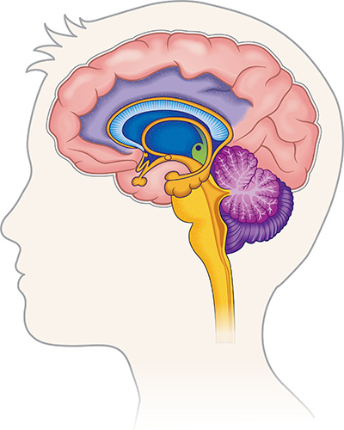
ILLUSTRATION BY JIM KOPP FOR TIME FOR KIDS
Students are learning that the brain is like a muscle. The more you use it, the stronger it gets.
What else can you do to give your brain a boost? “Learning to play a musical instrument seems to have benefits that go beyond just learning the instrument,” Hurley says. “And playing chess is really mind-expanding.”
But no matter what you are doing, Hurley stresses, the important thing is to step outside your comfort zone. “The more you challenge your mind,” he says, “the more your mind responds.”

